**UNIVERSITI MALAYSIA TERENGGANU**

**CSM3103 FRONT-END PROGRAMMING (K1)**

**BACHELOR OF COMPUTER SCIENCE (MOBILE COMPUTING) WITH HONORS**

**LAB 5 - JAVA SCRIPT**

**SEMESTER 4 2023/2024**

**Prepared for:**

DR. RABIEIL B MAMAT

**Prepared by:**

NUR ARINA BINTI ABDUL MALEK (S65361)

Lab 5

Task 1

1. Get the code from https://frend.odaje.biz/lab5/task1.html, and evaluate and test the code.
   1. What is the id of button and input field

= id of button is “button_change” while id of input field is “input_color”

* 1. What happened when you clicked change button and why?

= no, because there is no java script to make it makes changes in color.

1. Your mission: when the button is clicked, all occurrences of the word Black to be changed to the text in the input field.
2. Select the change button



1. Setting a click listener for button

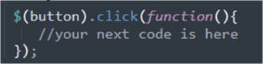

1. Retrieving and storing the input value

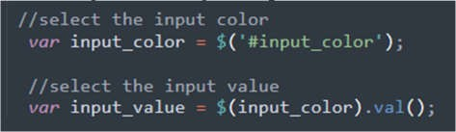

1. Select all appropriates black text by class selector

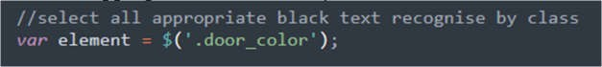

1. Replace the text with the input value



1. Test and evaluate your code. Comment on the new behaviour of your code

1. Basically, all those id and value in the code can be access directly without using any variables. **Rewrite the code by directly using the jQuery selector**
2. **Rewrite the code: can refer to task 2 if in doubt**
3. **Instead of input field, change it to dropdown which display available color understood by HTML (use select tag)**
4. **Retrieve the value from the select tag**
5. **Change the color of all appropriate text to selected color**

Task 2

1. Get the code from https://frend.odaje.biz/lab5/task2.html, and evaluate and test the code
   1. What id’s that exist in the code above?

= boxes and toggles

* 1. Open the file inside browser, what have you see in the browser?

= 3 boxes and toggles

* 1. Click any button, what happened? Why

= nothing happen

1. Your mission:
   1. Click on Toggle Colors button: Toggles the color between white and cardinal
   2. Click on Toggle Rounded Borders: Toggles the appearance of a border on the boxes
   3. Click add a new box: adds one new box to the container
2. Implements the following to accomplished your mission
   1. Add outlined class to each <div>. Refer to <div> for box2 as an example.

Save and open the file in browser

* + 1. What changes have you see?
    2. Add a click function to button_toggle_color, and implementing change color process

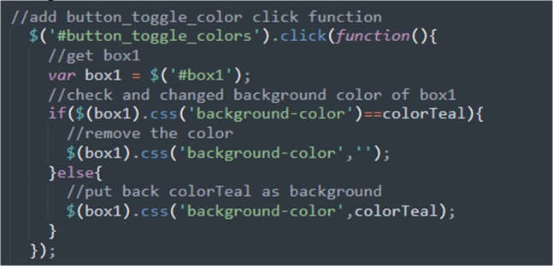

* + 1. Create an event listener for button_toggle_roundedges
    2. Inside the function add the following code

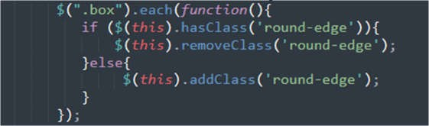

* + 1. Based on code in iv, can you modify a code in ii, so it change all box background and returned all to vanilla as well!
    2. Create an event listener for button_add_box.
    3. Inside the function put the following code
       1. Create new element using javascript



* + - 1. Get current number of element with class .box



* + - 1. With the current number of box create new id for new box

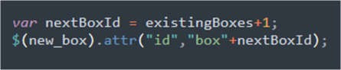

* + - 1. Add two classes (box and outlined) to new_box

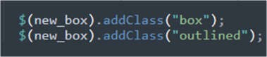

* + - 1. Finally, attached new box into box container

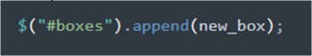

* + 1. Test and evaluate your code
    2. Modify the code above so that when button clicked, it only show one element which selected randomly .

Task 3

1. Get the code https://frend.odaje.biz/lab5/task3.html, and evaluate and test the code:
   1. Determine the id’s of each element

= name_input

= date_input

= year_input

= color_input

* 1. Recognise any input element that associated with the form
  2. Your Task are:
     1. Add DatePicker
     2. Use selectable interaction
     3. Use Sortable widget
     4. Use the tooltip

1. Inserting the datepicker into a form
   1. In the document ready function add this code



i. Can you set the date to limit the selectable date range to only include dates from the previous two weeks to the next two weeks.

1. Using selectable for enrolment type
   1. Comment radiobutton input
   2. Add the following code

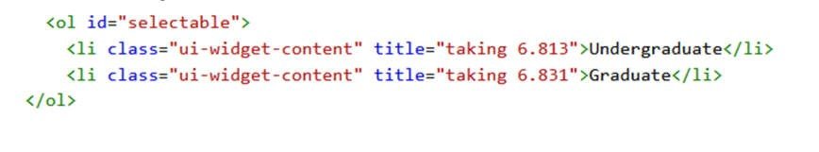

* 1. Add some css in style section

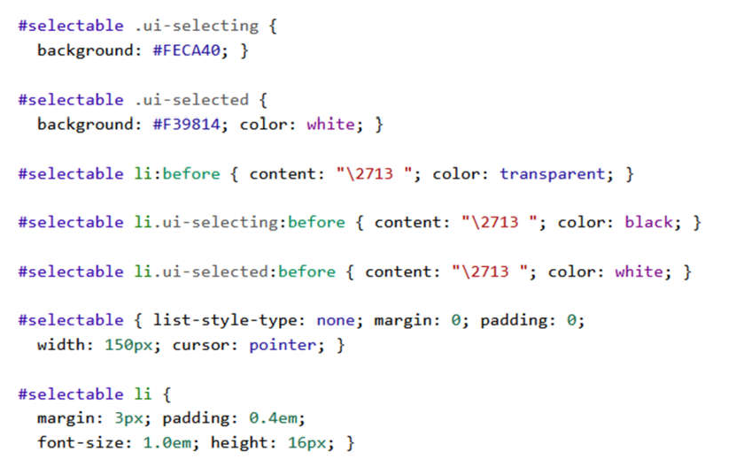

* 1. And control the behaviour using jQuery selector



* 1. How can we retrieve the value of the selected item?

1. Using sortable for the color input
   1. Comment all input element that related to color selections
   2. Replace with the following code

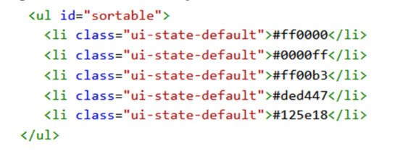

* 1. Adding a control to sort the list and disable the selection

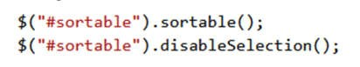

* 1. Check your output, now you can drag any color to a new position
  2. Add the following style to your code

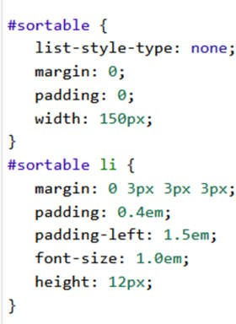

* 1. What do you think this CSS did? You can reverse the step to see the changes after and before the use of CSS
  2. Add the following span with class before color code in the <li> in (ii) above

<span class="ui-icon ui-icon-arrowthick-2-n-s"></span>

1. Adding a Tooltip
   1. Add the following code inside document ready function

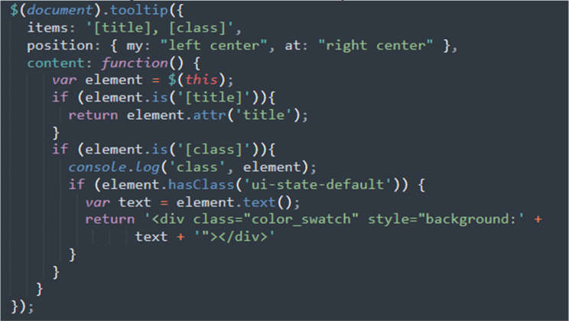

* 1. Add the following css



My work

Task 4

1. Get the code from https://frend.odaje.biz/lab5/task3.html, and evaluate and test the code.
2. Getting the context of the canvas
   1. Add the following code:

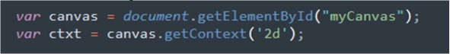

* + 1. What is the meaning of context in this case?

1. Drawing a triangle to canvas
   1. Setup the fillStyle, strokeStyle and linewidth.

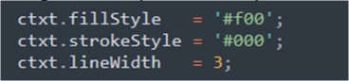

* 1. Describe the purpose of each method in (a)
  2. Put these codes into an appropriate function:

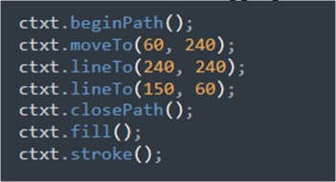

* 1. Test you code and evaluate the output
  2. Rearrange the position of coordinate and test your code.
  3. What is the use of moveTo methods above?

1. a new rotate triangle function
   1. Set the new position of the new triangle at the middle of previous triangle

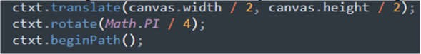

* 1. Start drawing a new triangle using a new coordinate

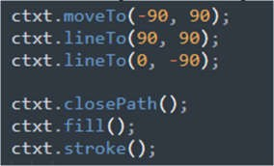

* 1. Test and evaluate your result.
  2. You can press the rotate many times, and can have different triangle at different location, why it’s happened?
  3. Clear the canvas

1. Put this code to clear the canvas



1. Can you write more better clear canvas , to clear all canvas

My work

